**CENTRALIZED AUTOMATION SYSTEM FOR PUBLIC LIGHTING WITH FAULT DETECTION (CASP LIGHT)**

|  |  |  |  |
| --- | --- | --- | --- |
| Anand. M  *Assistant Professor*  *Department of Mechatronics Engineering*  *SNS College of Technology, Coimbatore, India*  anand.m.mct@snsct.org | Kalaiselvi. P  *Assistant Professor*  *Department of Mechatronics Engineering*  *SNS College of Technology, Coimbatore, India*  kalai.p.mct@snsct.org | Nareshkumar. R  *B.E. Mechatronics Engineering*  *SNS College of Technology, Coimbatore, India*  naresh.r.mct.2020@snsct.org | Dhaneshraj. S  *B.E. Mechatronics Engineering*  *SNS College of Technology, Coimbatore, India*  dhanesh.s.mct.2020@snsct.org |
|  | Mukesh. V. R  *B.E. Mechatronics Engineering*  *SNS College of Technology, Coimbatore, India*  mukeshv.r.mct.2020@snsct.org | Dharshan. S  *B.E. Mechatronics Engineering*  *SNS College of Technology, Coimbatore, India*  dharshan.s.mct.2020@snsct.org |  |

**ABSTRACT:** This project introduces a Smart Urban Lighting Management System utilizing sensor technology to enhance efficiency, safety, and maintenance in public and street lighting. It employs Light-Dependent Resistors (LDRs) and microwave sensors to gather real-time data on day/night conditions, occupancy, and faults. The methodology includes sensor-based data collection, adaptive lighting control, and fault detection, enabling dynamic illumination adjustments based on environmental conditions. Development progress encompasses problem statement identification, literature review, PCB design, and a user-friendly web interface for real-time monitoring, PCB printing, product development, collaboration with local authorities, and result analysis for continuous improvement. The project aims to improve energy efficiency, cost savings, and safety by addressing issues like faulty streetlights through proactive maintenance facilitated by a user-friendly web interface and automated fault detection.

**KEYWORDS:** Smart Urban Lighting Management System, Light-Dependent Resistors (LDRs), Sensor technology

**INTRODUCTION:**

The "Centralized Automation System for Smart Public Lighting with Fault Detection" represents a revolutionary leap in the evolution of urban lighting infrastructure. This ambitious project introduces a centralized approach to public lighting, harnessing advanced automation and intelligent algorithms for a more synchronized and adaptive lighting system. The system's capability to dynamically adjust lighting levels based on real-time conditions, coupled with fault detection mechanisms, ensures not only energy efficiency but also the robustness of the entire lighting network. In the heart of this innovation is a commitment to proactive maintenance. The fault detection mechanisms continuously monitor the health of the lighting infrastructure, promptly identifying any issues that may arise. This real-time monitoring allows for swift and targeted maintenance interventions, minimizing downtime and ensuring that public spaces are consistently well-lit.

Beyond the technical advancements, the project carries significant implications for energy conservation. By optimizing lighting based on environmental factors such as ambient light, traffic patterns, and weather conditions, the system contributes to substantial energy savings, thereby reducing both operational costs and the environmental footprint associated with urban lighting. The benefits of this centralized automation extend beyond mere operational efficiency. The system promises a safer and more secure

urban environment by adapting lighting levels to real-time needs. Additionally, the improved aesthetics and ambiance resulting from dynamic lighting contribute to heightened community well-being, fostering social interaction and a sense of belonging.

As cities globally navigate the complexities of urbanization, the "Centralized Automation System for Smart Public Lighting with Fault Detection" emerges as a beacon of innovation. Its role in creating smarter, more sustainable, and resilient urban spaces cannot be overstated. However, successful implementation will hinge on collaborative efforts among stakeholders, including city planners, technology developers, and the community.

An inclusive and transparent approach to addressing challenges, such as privacy concerns and initial implementation costs, will be essential for realizing the full potential of this transformative system. In an era where the evolution of smart cities is at the forefront of urban development, this project stands poised to redefine the landscape of public lighting and pave the way for a more connected and intelligent urban future.

# CHAPTER 1

* 1. **Problem Statement**

In urban areas worldwide, conventional street lighting systems often suffer from several critical deficiencies, leading to inefficiencies, safety concerns, and increased maintenance costs. Firstly, these systems tend to operate on fixed schedules, disregarding actual lighting needs based on environmental conditions such as natural daylight levels and human presence. As a result, they contribute significantly to unnecessary energy consumption and light pollution, exacerbating environmental and financial burdens. Moreover, the lack of timely fault detection mechanisms within these systems exacerbates safety risks and operational challenges. Burnt-out bulbs, malfunctioning fixtures, or darkened areas often go unnoticed until reported by the public, leading to increased safety hazards, decreased visibility, and prolonged periods of inadequate lighting.

Furthermore, the absence of centralized control exacerbates the inefficiencies of urban lighting management. Without a unified platform for monitoring and controlling lighting infrastructure, authorities face challenges in optimizing maintenance schedules, allocating resources effectively, and responding promptly to emerging issues. Consequently, this decentralized approach leads to suboptimal resource utilization and higher operational costs.

Additionally, safety concerns arise due to poorly lit or darkened areas within urban environments. These areas become breeding grounds for criminal activities, accidents, and public discomfort, undermining the overall safety and liability of the community. Without adequate illumination, pedestrians, cyclists, and motorists face heightened risks of accidents, collisions, and personal harm.

Finally, the lack of real-time data further compounds the challenges of urban lighting management. Without access to accurate and up-to-date information on lighting conditions, occupancy patterns, and fault occurrences, authorities struggle to make informed decisions regarding lighting control strategies, maintenance priorities, and resource allocations.

The current state of urban lighting systems is characterized by inefficiencies, safety hazards, and operational challenges stemming from fixed schedules, delayed fault detection, decentralized control, safety concerns, and limited data availability.

Addressing these issues necessitates the development and implementation of a sophisticated Smart Urban Lighting Management System that leverages sensor technology, intelligent control mechanisms, and data-driven insights to enhance efficiency, safety, and maintenance practices in urban environments.

**1.2 Project justification**  
 The justification for addressing the problems inherent in conventional urban lighting systems lies in the significant impact they have on various aspects of urban life, including environmental sustainability, public safety, and operational efficiency.

Firstly, the inefficiencies in these systems, characterized by fixed schedules and lack of responsiveness to actual lighting needs, result in unnecessary energy consumption and light pollution, contributing to environmental degradation and increased operational costs. Moreover, delayed fault detection exacerbates safety risks, as darkened areas pose hazards to pedestrians, cyclists, and motorists, leading to accidents and potential criminal activities.

Additionally, the decentralized nature of current lighting management systems leads to suboptimal resource allocation and higher operational costs, further straining municipal budgets. Furthermore, the absence of real-time data impedes informed decision-making, hindering efforts to improve energy efficiency, enhance safety measures, and allocate resources effectively.

Therefore, addressing these problems is essential for creating more sustainable, safe, and efficient urban environments that promote the well-being and quality of life for residents and visitors alike.

**1.3 Methodology**

**1.3.1 Existing methodology**

1. Traditional Street Lighting:

* Fixed brightness: Inefficient energy consumption, especially during low traffic periods.
* Limited control: Difficult to adjust brightness based on real-time conditions.
* Reactive maintenance: Faulty lights remain undetected until reported, leading to prolonged downtime.
* No data collection: Lack of data insights for optimization and analysis.

2. Time-based scheduling:

* Inaccurate adjustments: Does not consider real-time factors like traffic or weather.
* Inefficient energy use: Lights remain on unnecessarily during low occupancy periods.
* Limited adaptability: Cannot respond to sudden changes in environment.

3. Motion sensor-based lighting:

* False triggers: PIR sensors can be triggered by sources of heat other than human or vehicle movement
* Limited coverage: Sensors may not detect activity in all areas.
* High installation and maintenance costs: Extensive sensor network required for comprehensive coverage.

4. Centralized control systems

* Single point of failure: System vulnerability to outages or disruptions.
* Limited scalability: Difficulty in scaling to large or geographically dispersed deployments.
* High infrastructure costs: Requires significant investment in central infrastructure.

5. Proprietary communication protocols:

* Limited vendor interoperability: Restrictions on integrating with other systems and devices.
* Higher costs: Increased dependence on specific vendors for equipment and maintenance.
* Reduced flexibility: Difficulty in adapting to future technological advancements.

6. Manual data collection and analysis:

* Time-consuming and laborious: Requires significant human resources.
* Error-prone: Increased risk of inaccurate data collection and analysis.
* Limited insights: Difficulty in identifying trends and patterns for optimal decision-making.

7. Lack of fault detection and reporting:

* Prolonged downtime: Faulty lights remain undetected and unaddressed.
* Increased maintenance costs: Reactive maintenance approach leads to unnecessary repairs.
* Reduced system efficiency: Faulty lights can contribute to energy waste and safety risks.

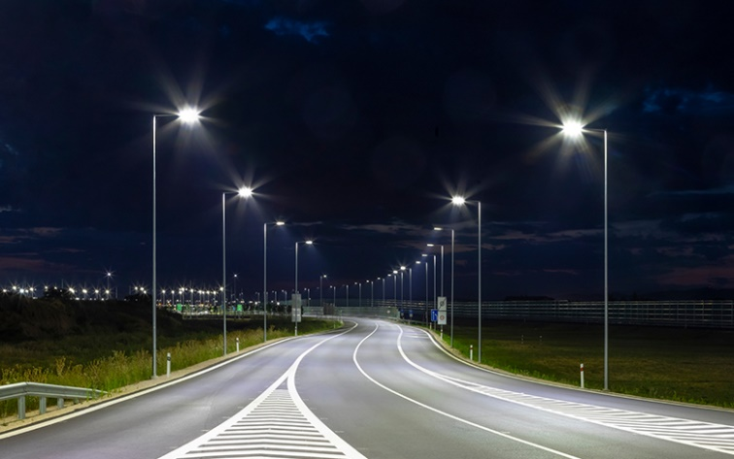



Fig. 1. Timer Control – Existing Methodology

**1.3.2 PROPOSED METHODOLOGY**

* This project aims to enhance urban lighting by making public and street lights smarter through the use of sensors to detect day/night conditions, occupancy, and faults.
* It also includes an intelligent system that allows streetlights to communicate and control their illumination levels and notify if there is any fault found in the light to the server.
* An essential aspect is monitoring electricity consumption, much like monitoring home energy bills.

In this project, we can develop a sophisticated urban lighting management system (Fig 2) that can utilize a range of sensors, including Light-Dependent Resistors (LDRs) and microwave sensors. These sensors can enable us to collect data on ambient light levels, occupancy, and importantly, fault detection. Real-time data processing can allow us to intelligently control lighting levels based on day/night conditions and occupancy, greatly improving energy efficiency and reducing unnecessary power consumption. One standout feature can be our fault detection mechanism, which can autonomously identify and report issues with streetlights, ensuring swift maintenance and minimal downtime. We can also closely monitor power consumption using SELEC EM2M Energy Meter, and we can establish a centralized control system with ESP Now for seamless data transmission. For user convenience, we can implement a local server and a user-friendly web interface, enabling real-time monitoring and control. Our maintenance and optimization protocols can be geared toward sustaining high system performance

.

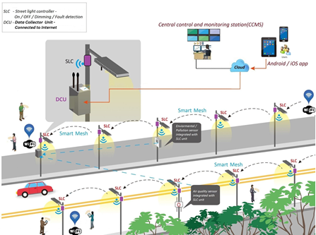

Fig. 2 Pictorial Representation of Proposed Methodology

# CHAPTER 2

**2. RELATED WORK**

**2.1 Centralized Control System for Smart Street Lights Based on STM32 and LoRa *Qu, Yuanchi, et.al:***

This paper proposes a cost-effective solution for smart street lighting utilizing the STM32 microcontroller and LoRa long-range communication technology. The system comprises a centralized control unit and individual lamp controllers, enabling adaptive brightness adjustments based on real-time requirements. Communication between the units occurs through the Modbus RTU protocol, facilitating "on-demand lighting" for optimal energy efficiency. Furthermore, an adaptive rate algorithm optimizes LoRa network communication, ensuring reliable data transfer and scalability for widespread implementation in intelligent street lamp control systems.

**2.2 Smart Street Light For Energy Saving Based On Vehicular Traffic *Bhatti, Jawad A., et al:***

It presents a novel approach to transforming conventional streetlights into smart ones by leveraging existing surveillance cameras and a powerful Convolutional Neural Network (CNN) algorithm, specifically YOLOv5. This system analyzes camera footage to detect and track pedestrian and vehicular traffic in real-time, enabling dynamic adjustments in light intensity based on the observed activity. This integration of existing infrastructure with a control module and Jetson Nano processing unit offers a practical and sustainable solution for energy management in street lighting, leading to significant cost reductions compared to traditional LED streetlights.

**2.3. A Study on IoT based smart street light systems *Arjun, P., et al:***

*T*his study advocates for the adoption of advanced smart streetlight systems that utilize energy-efficient LED lamps for reduced heat emission, lower energy consumption, and extended lifespan. To further enhance energy efficiency, the system incorporates Light Dependent Resistors (LDRs) and Passive Infrared Sensors (PIRs) for automated light adjustments based on ambient light conditions and movement detection, minimizing electricity loss. Additionally, a ZnO coating applied to the streetlight casings protects against dust and moisture, ensuring efficient lighting performance. The study employed a sol-gel deposition process to achieve uniform ZnO nanoparticle coatings on silica glass substrates, verified by Scanning Electron Microscopy (SEM) images.

**2.4. Monitoring Street Light Using IoT Technology to Detect Fault Automatically *Raja, R., and S. Regina:***

In India, manual street light maintenance often leads to significant power wastage and inefficiencies, as lights remain on unnecessarily, particularly during daylight or in low-traffic areas. Addressing these challenges, this paper proposes a Smart Street Light Monitoring system utilizing the Internet of Things (IoT). This system automates light control, adjusts intensity based on real-time conditions, and detects faults, resulting in reduced energy consumption, operating costs, and improved infrastructure management. Real-time fault information enables timely repairs and maintenance, further enhancing system efficiency and minimizing downtime.

**2.5. A Smart Street Light System With Auto Fault Detection *Saini, Piyush, et al:***

This paper addresses the increasing demand for alternative energy solutions by focusing on reducing energy consumption in street lighting. It explores a microcontroller-based smart street light system that utilizes LED lights, brightness and motion sensors, and a communication network. The system anticipates vehicle movement and automatically adjusts light intensity accordingly, dimming or turning off lights in the absence of activity. This approach optimizes energy usage, particularly beneficial in low-traffic areas, and minimizes unnecessary power consumption.

**2.6. Battery-less Energy Autonomous Street Light Management System for Smart City *Mohanty, Prajnyajit, et al:***

This manuscript proposes a supercapacitor-based smart street light system, utilizing IoT, as a real-time, energy-efficient alternative. Designed for autonomy, the system prevents unnecessary electricity consumption. With an average current consumption of 619.14 A and power consumption of 2.022 mW, it integrates three charging schemes for optimized energy harvesting. Utilizing a solar cell, it generates up to 66 mW from ambient sunlight and artificial light. Incorporating LoRaWAN for communication, the system demonstrates a 761 m range in real-world tests, ensuring seamless operation and offering a sustainable solution for urban lighting challenges**.**

**2.7. Smart Street Light System *Ambre, Omkar V., et al:***

Picture strolling through a dimming street at night, the result of a smart street light system powered by the IoT. This innovative system employs sensors and cameras to dynamically optimize and automate street lighting, offering an efficient and cost-effective solution. Through IoT sensors, remote monitoring allows adjustments based on traffic and weather conditions. The benefits include energy savings, heightened public safety, and a reduced carbon footprint, contributing to sustainable and environmentally friendly cities.

# CHAPTER 3

**3. WORKING OF PROPOSED SYSTEM**

**3.1 Schematic Diagram**

The schematic diagram illustrates the key circuit connections within the centralized streetlight control system, leveraging an ESP8266 microcontroller for smart functionality. The ESP8266 interfaces with Light Dependent Resistors (LDRs) and microwave sensors to dynamically adjust streetlight illumination based on environmental conditions, promoting energy efficiency.

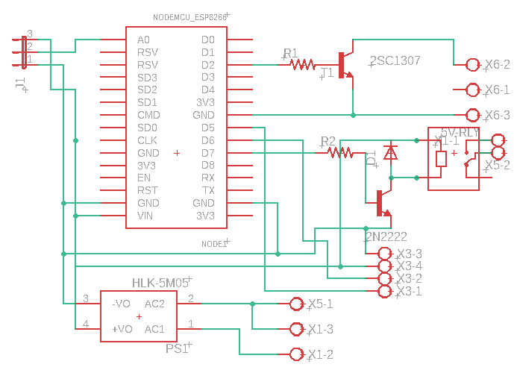The circuit incorporates a relay for seamless control of streetlight activation and deactivation. Additionally, a power meter, specifically the Selec MFM376, is integrated to monitor and record real-time power consumption, contributing to data-driven insights for optimizing energy usage.

Fig.3 Schematic Diagram of Smart Street light Controller

|  |  |  |
| --- | --- | --- |
| S.No | Component Name | Specification |
| 1 | ESP8266 | 9 Digital I/O, 1 Analog I/O, PWM, Wi-Fi |
| 2 | Hi-Link 5M05 | 5 Volt – 5 Watts |
| 3 | ACS712 | 0-5A Current sensing |
| 4 | 5v Relay | 250VAC/120VDC(7A) |
| 5 | TIP122 NPN Darlington Transistor | 100V – 5A |
| 6 | BC547 | Switching Purpose NPN Transistor |

Table 1: Schematic Diagram of Smart Street light Controller

The components used in the project include an ESP8266 microcontroller, featuring 9 digital I/O pins, 1 analog I/O pin, PWM capabilities, and Wi-Fi connectivity for data transmission. Power regulation is handled by the Hi-Link 5M05 module, providing stable 5 volts at a maximum of 5 watts. Current sensing is facilitated by the ACS712 sensor, capable of measuring currents in the range of 0 to 5 amperes. A 5-volt relay with a capacity of 250VAC or 120VDC at 7 amperes is employed for switching purposes, alongside the TIP122 NPN Darlington transistor, supporting voltages up to 100 volts and currents up to 5 amperes. Additionally, the BC547 NPN transistor is utilized for switching applications.

**3.2 Data Transmission**

The Data is transmitted from the slave street light to master through ESPNOW Protocol. ESP-NOW is a low-power communication protocol developed by Espressif Systems for direct peer-to-peer communication between ESP8266 and ESP32 devices without the need for a traditional Wi-Fi network. It offers simplicity in setup, low power consumption, and high throughput, making it ideal for battery-operated devices and real-time data exchange applications. With customizable payload options and robust communication features, ESP-NOW facilitates reliable data transmission in challenging environments. It is compatible with ESP8266 and ESP32 microcontrollers, providing a versatile solution for IoT projects requiring decentralized communication and efficient wireless connectivity. This technology works with both Wi-Fi and Bluetooth LE and is compatible with various Espressif microcontrollers (SoCs) like ESP8266, ESP32, and their S and C series. Espressif's innovative Long Range (LR) Wi-Fi mode extends wireless connections up to one kilometre, significantly surpassing the reach of traditional 802.11b. This enhanced mode boasts improved reception sensitivity, stronger resistance to interference, and a longer transmission distance, making it ideal for various applications.

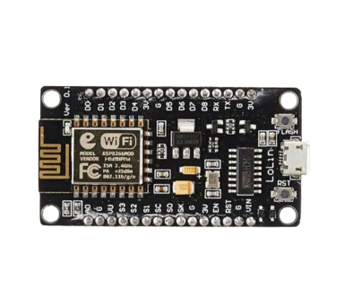

Data_1



Data_2 + Data_1



Data_3+Data_2+Data_1

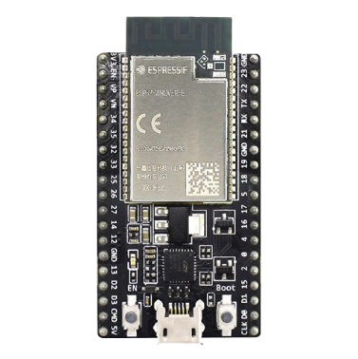



Data 1,2,3

Fig.4 ESP NOW Network

ESP-NOW wireless communication protocol based on the data-link layer, which reduces the five layers of the OSI model to only one. This way, the data need not be transmitted through the network layer, the transport layer, the session layer, the presentation layer, and the application layer. Also, there is no need for packet headers or unpackers on each layer, which leads to a quick response reducing the delay caused by packet loss in congested networks.

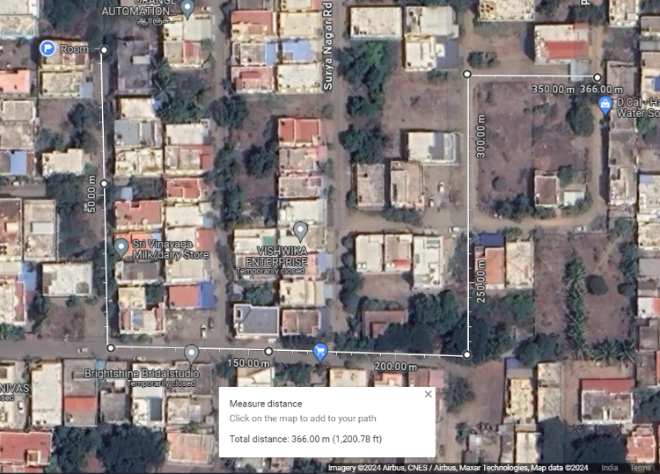

Fig 5: Real time testing of communication

between street lights

|  |  |
| --- | --- |
| Number of Lights Used | 7 |
| Total Distance | 366m |
| Avg. Distance between Lights | 50m |
| Time taken to report fault | <2 seconds |

Table 2: Analysis of communication in real time

With a total of 7 lights utilized along a span of 366 meters, the average distance between each light stands at approximately 50 meters (as shown in Table 3.1). In the event of a fault, the system demonstrates remarkable efficiency, with fault reporting achieved in less than 2 seconds. This swift response time ensures prompt detection and resolution, maintaining the functionality and reliability of the lighting infrastructure.

**3.3 Dimmer Circuit**

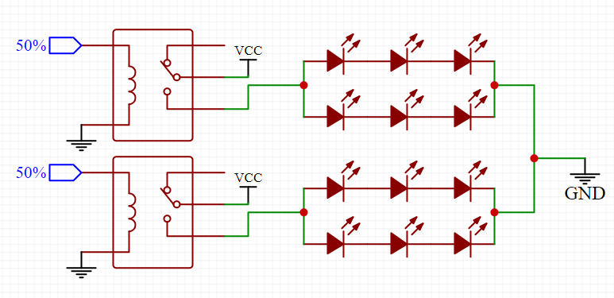

Fig.6 Schematic Diagram of the Dimmer Circuit

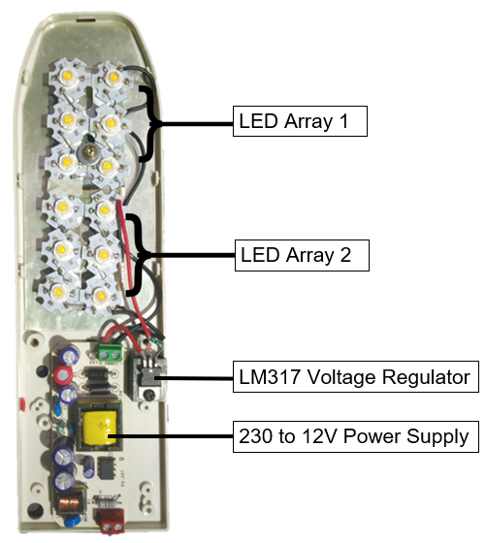

Fig.7: Developed LED Street Light with Dimmer Circuit

LED street light brightness is adjusted efficiently by dividing the LED arrays into two independently controlled groups. Under normal conditions, only one group is active, providing adequate illumination. When motion is detected, the second group instantly activates, boosting brightness for improved visibility. This innovative approach simplifies the circuit, eliminating the need for complex, expensive components, ultimately leading to cost reduction.

|  |  |
| --- | --- |
| Input | 150-230V AC, 0.5A, 50-60Hz |
| LED Input | 10-11 V DC - 2A |
| No. of LED | 12 (6X2) - 2 Array |
| Full brightness | 24 Watts |
| Half Brightness | 12 Watts |

Table 3: Specification of the Developed LED Street Light

The input power specifications for the project are 150-230 volts AC with a current rating of 0.5 amperes and a frequency range of 50-60 hertz. The LED input voltage requirement is 10-11 volts DC with a maximum current draw of 2 amperes. The project utilizes a total of 12 LEDs arranged in two arrays of six LEDs each. At full brightness, the LEDs consume 24 watts of power, while at half brightness, they consume 12 watts.

**3.4 PCB DESIGN**

The Printed Circuit Board (PCB) for the centralized streetlight control system serves as a crucial component, providing a structured and efficient platform for the integration of various elements. This section outlines the key aspects of the PCB design, emphasizing its role in facilitating seamless functionality. At its core, the PCB serves as a physical foundation for mounting and interconnecting essential electronic components, including microcontrollers, sensors, communication modules, and power management units. Through strategic layout and routing, the PCB optimizes the spatial arrangement of these components, minimizing signal interference, and maximizing operational 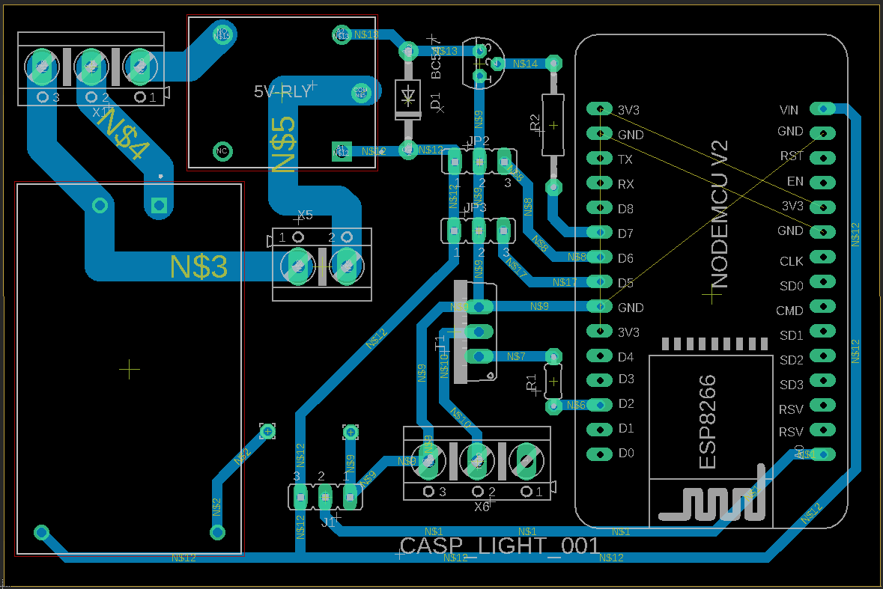reliability.

Fig. 8: PCB Design of the Individual Light

Controller (6X5 cm)

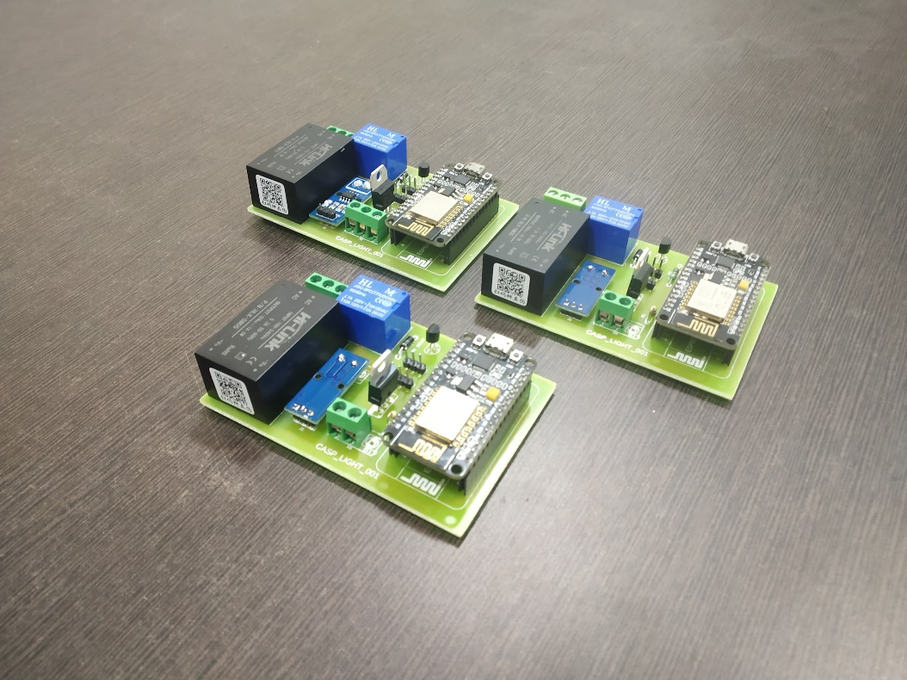

Fig. 9: Real time image of the assembled PCB

|  |  |
| --- | --- |
| Input | 150-230V AC, 50-60Hz |
| LED Handling Range | 5-100V DC - 5A |
| Communication Range | 85m (without Antenna) |

Table. 4: Specification of the Individual Light Controller

The input power for the project ranges from 150 to 230 volts AC at a frequency of 50 to 60 hertz. The LED handling range is from 5 to 100 volts DC with a maximum current handling capacity of 5 amperes. The communication range of the system is up to 85 meters without the use of an external antenna.

**3.5 MAIN CONTROLLER**

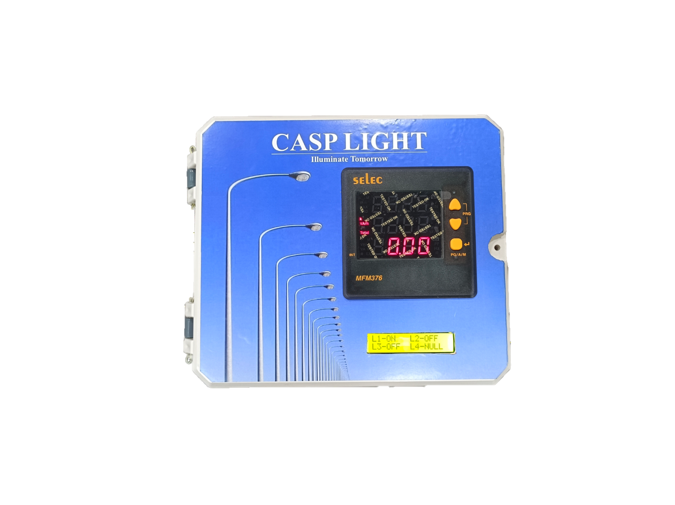

Fig. 10: Real time image of the Main Controller

The cabinet for the main controller housing the Local Server for street lights, alongside a Human-Machine Interface (HMI), is designed as a robust and weatherproof structure, constructed from durable materials like stainless steel or aluminium. Its compact dimensions are optimized for accommodating all components efficiently while ensuring space efficiency. Equipped with ventilation systems to prevent overheating, it also incorporates a reliable power supply mechanism, including backup options like batteries or generators, to ensure uninterrupted operation.

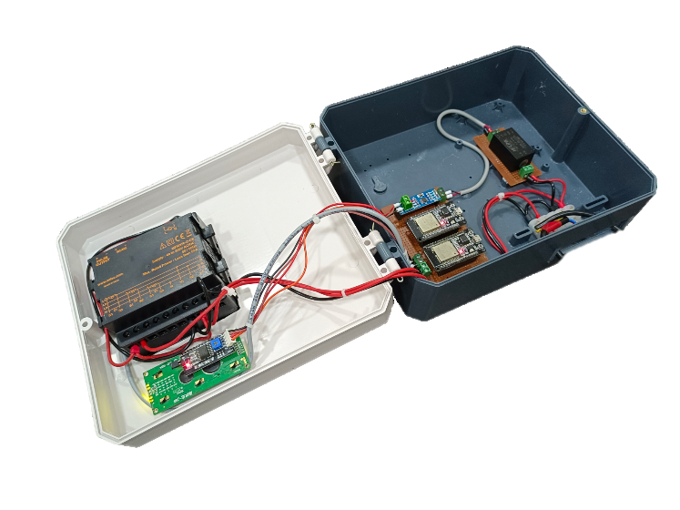

Fig. 11: Control Circuit with Energy Meter

The main controller orchestrates data processing, fault detection, and scheduling, while the Local Server stores and analyzes streetlight data. The HMI, typically a touchscreen display, provides an intuitive interface for user interaction, facilitating monitoring, configuration, and troubleshooting. Security features like locks and encryption ensure system integrity, while provisions for remote connectivity enable centralized management and updates. Environmental sensors may also be integrated to gather additional data for urban planning and environmental monitoring purposes. Overall, the cabinet serves as a critical infrastructure component in smart city initiatives, contributing to enhanced efficiency, sustainability, and safety in urban environments.

**3.6 WEB APPLICATION / DASHBOARD OF THE IOT SYSTEM**



Fig. 12: Login Page of the Web App – CASP LIGHT

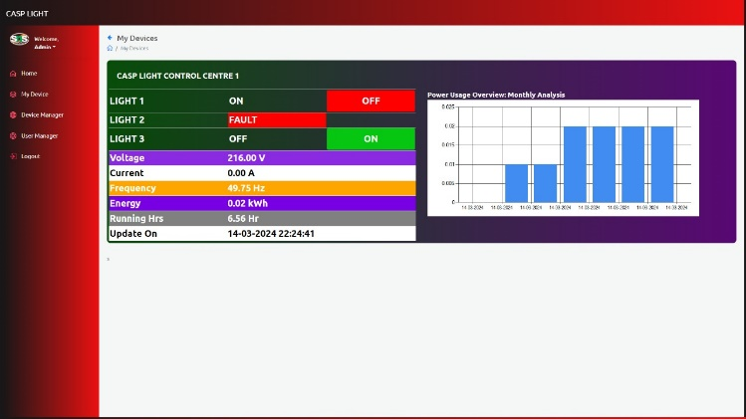

Fig. 13: User interface of the Smart Street light system

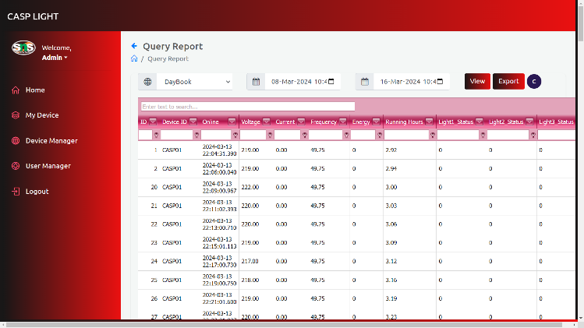The development of a web dashboard for monitoring and control is a significant advancement in the centralized streetlight control system. The web dashboard provides real-time monitoring capabilities, allowing users to track the status of individual streetlights, sensor data (e.g., light levels and occupancy), and the overall system health. Users can interactively control streetlights through the dashboard. This includes the ability to manually adjust illumination levels, activate or deactivate specific lights, and override the system based on real-time requirements.

Fig. 14: History and Report Generator of the Web App

The developed web application comprises functionalities for users to access historical data and generate reports. This feature allows users to track the performance and usage patterns of streetlights over time, aiding in data analysis and decision-making.

3.5.1 Fault Detection and Reporting:

The dashboard incorporates a fault detection mechanism, enabling automatic identification of issues within the streetlight system. Faults are reported in real-time, allowing for prompt responses and minimizing downtime.

3.5.2 Energy Consumption Insights:

Users can access detailed insights into energy consumption patterns through the web dashboard. This feature is essential for assessing the system's efficiency, identifying potential optimizations, and managing energy costs effectively.

3.5.3 Responsive Design:

The web dashboard is designed with responsiveness in mind, allowing users to access and control the streetlight system from various devices, including desktops, tablets, and smartphones.

3.5.4 Data Logging and Historical Analysis:

The dashboard facilitates data logging, storing historical information about system performance, faults, and energy consumption. This data can be analysed over time to identify trends, patterns, and areas for improvement.

# CHAPTER 5

# 5. SOFTWARES INCORPORATED:

**5.1 Microsoft Visual Studio**

Microsoft Visual Studio, often shortened to VS, is a comprehensive development environment designed to empower programmers to build various software applications. From desktop programs and web apps to mobile games and cloud solutions, VS offers a robust suite of tools for writing, editing, and debugging code, managing versions, crafting user interfaces, and integrating diverse programming languages. With both free and paid versions catering to individuals and teams alike, VS remains a popular choice for developers of all levels.



Fig. 15: Microsoft Visual Studio

**5.1.4 ARDUINO IDE (2.2.1)**

The Arduino IDE stands as a pivotal tool in the realm of embedded systems, offering a streamlined environment for programming Arduino and ESP microcontrollers. With a user-friendly interface, it facilitates code creation, compilation, and uploading onto Arduino boards seamlessly. Designed for compatibility with Windows, macOS, and Linux, it ensures accessibility across diverse operating systems. Its programming language, a simplified version of C and C++, incorporates beginner-friendly structures like setup () and loop ().



Fig. 16: Arduino IDE

# CHAPTER 6

**6.1 Results and Conclusion:**

Fig 17: Power consumption difference between existing and the dimmer based proposed street lighting systems

The diagram of Figure 11 below shows a bar graph indicating the extent of change between the current street lighting system and the proposed dimmer-based street lighting system. Two tests were carried out; one on power reduction by illumination adjustment while the other did not alter illumination. Moreover, different wattage lamps were used to test how the circuit was functioning. The outcome demonstrates that compared to the present method, dimmer-controlled street lighting utilizes less energy.

The amount of energy conserved each night by an adaptive LED street light rated at 36 watts can be calculated using the following formula:

*Energy Saved = $\frac{Energy saved by adaptive illumination }{Energy used with standard illumination }$ x 100 %*

*= $\frac{0.375- 0.26 }{0.375 }$ x 100 %*

*= $\frac{0.115 }{0.375 }$ x 100 %*

*Energy Saved = 30.7* %

According to Tamil Nadu Generation and Distribution Corporation (TANGEDCO) Tariff Order, 2023, for Public Lighting the energy charges is Rs. 8.15/Unit. For a thousand 36 Watts LED Light the Cost savings can be calculated as follows:

Without Adaptive illumination,

*Cost = 0.375 kWh x 1000 x 8.15 ₹ = ₹ 3056 / Night*

*Cost for One Year = ₹ 11,15,531*

With Adaptive Illumination,

*Cost = 0. kWh x 1000 x 8.15 ₹ = ₹ 2119 / Night*

*Cost for One Year = ₹ 7,73,435*

Hence approximately 3.42 lakh rupees can be reduced with the adaptive illumination system.

The outcomes of the project demonstrate significant progress towards the development of an advanced streetlight control system, characterized by robust communication, efficient monitoring and control capabilities, and active engagement with stakeholders. Through successful testing of ESPNOW communication and integration of sensor technologies, the project has laid a strong foundation for real-time data transmission and adaptive lighting control, promising improved efficiency and responsiveness within urban lighting infrastructure.

Looking ahead, the identified future scopes offer exciting opportunities for further enhancement and innovation within the streetlight control system. Exploration of advanced communication protocols, integration of emerging technologies, and research into energy harvesting solutions hold the potential to elevate the system's capabilities to new heights, promoting sustainability, resilience, and intelligence.

In conclusion, the project represents a significant advancement in centralized streetlight control, with tangible outcomes and promising avenues for future development. By leveraging cutting-edge technologies and fostering collaboration with stakeholders, the project aims to contribute towards creating safer, more sustainable, and liveable urban environments. Through continued innovation and engagement, the vision of an efficient, adaptive, and community-centric streetlight control system can be realized, ultimately enhancing quality of life for residents and contributing towards broader urban sustainability goals.

**References:**

1] Qu, Yuanchi, Yanhua Yang, and Yaoyao Li. "Centralized Control System for Smart Street Lights Based on STM32 and LoRa." Journal of Physics: Conference Series. Vol. 2216. No. 1. IOP Publishing, 2022.

2] Bhatti, Jawad A., et al. "Smart Street light for energy saving based on vehicular traffic volume." 2022 Global Conference on Wireless and Optical Technologies (GCWOT). IEEE, 2022.

3] Raja, R., and S. Regina. "Monitoring Street Light Using IoT Technology to Detect Fault Automatically."

4] Arjun, P., et al. "A Study on IoT based smart street light systems." 2019 IEEE international conference on system, computation, automation and networking (ICSCAN). IEEE, 2019.

5] Saini, Piyush, et al. "A smart street light system with auto fault detection." Pramana Research Journal 8.8 (2018): 167-176.

6]Mohanty, Prajnyajit, et al. "bSlight: Battery-less Energy Autonomous Street Light Management System for Smart City." IEEE Transactions on Sustainable Computing (2023).

7] Ambre, Omkar V., et al. "Smart Street Light System." International Journal of Advanced Research in Science and Communication. (2023

8] Kanthi, M., and Ravilla Dilli. "Smart streetlight system using mobile applications: secured fault detection and diagnosis with optimal powers." Wireless Networks (2023): 1-14.

9] Takruri, Maen, et al. "Design and Implementation of a Real-Time Street Light Dimming System Based on a Hybrid Control Architecture." International Journal of Distributed Sensor Networks 2023 (2023).

10] Yang, Yu-Sheng, et al. "An implementation of high efficient smart street light management system for smart city." IEEE Access 8 (2020): 38568-38585.

11] Abdullah, Aziera, et al. "Smart street light using intensity controller." 2018 7th international conference on computer and communication engineering (ICCCE). IEEE, 2018.

12] Dheena, PP Fathima, et al. "IOT based smart street light management system." 2017 IEEE international conference on circuits and systems (ICCS). IEEE, 2017.

13] Wu, Yue, et al. "Design of new intelligent street light control system." IEEE ICCA 2010. IEEE, 2010.

14] Müllner, Reinhard, and Andreas Riener. "An energy efficient pedestrian aware Smart Street Lighting system." International Journal of Pervasive Computing and Communications 7.2 (2011): 147-161.

15] Veena, P. C., et al. "Smart Street light system based on image processing." 2016 International Conference on Circuit, Power and Computing Technologies (ICCPCT). IEEE, 2016.